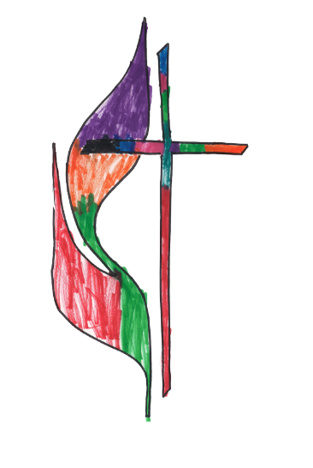
Tuition for 2021-2022 School Year

Monthly Service | Child’s Age | Monthly Rate
Childcare 7:30-5:30
 | Infants (6wks-12mo) | $625
 | Toddlers (12 mo-24 mo) | $610
Preschool 8:15am-11:45am (M-F)
 | 2 years old | $270
 | 3 years old | $260
Extended Care 11:45am-5:30pm (includes Sunrise routine) | 4 years old | $250
 | 2-4 years old | $330

Daily Services |  | Daily Rate
Sunrise Routine 7:30am-8:30am
PRESCHOOL ONLY | 2-4 years old | $3

F.U.M.P. bills one Month in advance.

School Registration Fee- $180, due at registration.
School Supply Fee- $120, due in September
If you’d like your child to attend summer fun only, registration fee is $75
Summer School Supply Fee- $50

Yearly Registration happens every January for the following school year.
Summer Fun Registration happens every February (Preschool aged children)

